SALUMET – 24th November 2014.

Happily, we now resume meetings following a break that Salumet might well describe as: the mere blink of an eye—time being that little bit different in spirit. There is still some scaffolding outside the house but inside is fine, and we are all most pleased to be able to continue onward.

Audio link:
http://www.salumetandfriends.org/resources/2014_11_24+salumet1.mp3

Good evening.
General greetings
I am happy to join with you.
George: We are most happy Salumet to have you with us.
To feel the union between you all this time, gladdens us all. I know that you feel that time has passed so slowly, but I assure you my dear friends, that what you have been up to has been known to us also. As you know, time in our world is so different, so different that it is difficult to explain, and I know that on this Earthly plain, it is a hard lesson to come to terms with; but I am so happy for you all that the strength of your love for each other and therefore for this group of people, is strong. I would like you just for a moment or two, to feel that energy that exists between you. I would like you to just feel the energy; do not think about it, but just feel what it is like, how strong it is. All of you my dear friends, have joined together and no matter how far you travel, or how little you come together, that union is so strong and can never be broken. So let us take this moment to feel the energy between you. If any of you do feel different, then please say so to the others. Short pause
George: Oh yes, I’m sure the energy is there amongst us all.
Lilian: And the feeling of (being) pleased to see one another.
Sara: Yes, a very comfortable bond.
Graham: It almost feels like coming home. Affirmations
George: It seems almost a stronger union, for having not had meetings for a short period.
Sara: Yes, I think possibly we are hungry for each other!
Chuckles
There is a saying on your world about absence and I believe it is apt on this occasion.
George: Yes: ‘Absence makes the heart grow fonder.’
We will replace the heart and say the ‘Spirit’. Affirmations
Lilian: Yes, it’s a different kind of togetherness, isn’t it?
Yes—it cannot be seen with any physical eyes, but as I have told you many times: to feel rather than to think and it is beautiful to behold. I can tell you that all of you are shining like beacons of light. I think because it has been some time, that I will not take questions from you, but allow you just to build upon this beautiful energy, which has been created by each and every one of you. But what I will say to you, is that in the months to come, there is much to give to you, there is much for you to experience, and it is up to each one of you, to fulfil whatever it is that you feel your lives are about. I wish you now to take full responsibility for every word, every action and most importantly every thought that you have. This may sound like an easy task, but let me reassure you my dear friends, it is not.
Affirmations
George: I have a thought Salumet. During this brief period when we have not met, I have been writing about the Aether, and I have felt much guidance and I am most grateful and I did not exactly do my own planning from the start, but a set of 15 chapters seem to have presented themselves one after the other and that next book on the nature of the Aether and it’s part in Creation is well underway, so thank you very much.
You are a fountain of knowledge within this group, but I do have to say, although you are aware of the help we give to you, sometimes you close your ears and do not listen to us.
George: Oh dear.
Yes—not in a negative way so much, as that you have to be aware of your Earthly body, as well as your spiritual body. There is a very fine balance and I wish this for all of you, not just our dear friend the writer. You are influenced at all times and that is why I have said you must take full responsibility for all that you think and all that you do.
Pause
Yes, I do not hear too many words (chuckles), but I hope it gives you some time to think and to move forward. After all, that is part of the aim of this group—not only to be messengers of Spirit, but to grow, to recognise where you have come from, to acknowledge that Spirit that you all are.
George: Yes, we must take full responsibility. But as regards—when I say ‘help’ from Spirit, it is as if there is a catalyst influencing thoughts.
Yes, you are being helped greatly, but you have earned that help my dear friend. You have put pen to paper—words sometimes influenced by us, but other times through sheer work—those words have been put down to paper.
George: Yes, the difficulty sometimes is bringing together the help from Spirit and humanity’s scientific research and trying to combine the two.
Yes, you will never combine the two in your lifetime, but I would say you are trying very hard (Thank you). The knowledge of Spirit is still very young, although we are completely satisfied with what is happening in your world. The knowledge of Spirit is becoming greater and greater, but as with all good things, it does not happen quickly—yes. Would anyone wish to speak—not question, but rather how they have been feeling?
Sara: I feel very happy with my piano opportunity at the moment, because it’s giving me a lot of pleasure and I think inspiration too. I have felt definitely the presence of helpers with me and they help me to create some more music and I hope I will allow my helpers the chance to give me more in future. It’s been very joyful to have this opportunity.
Yes, you—I do not often tell you personal details, but you could help with children and your music.
Sara: Yes, I think—I had a conversation that was leading to that recently and I feel there will be scope for that.
Yes, you must remain open to it, and if you do, then it can happen. It will also benefit you, as well as the children.
Sara: Yes, I feel that would be a good development, thank you for that. I sense it’s going to happen in this place (Yes), because it’s a good opportunity to combine the music with interaction with people as they come.
Yes, music lifts the Spirit. I know that is something that is said on your Earth plain quite frequently, but it does lift the Spirit, it raises you to another level. So you may find that is the direction that you take.
Sara: Right, yes that’s fine, whatever direction, I’ll be happy to flow with it—hopefully.
Yes, we can guide you, but we would wish also that you strive for what you desire, because it is an innate desire, a desire that comes from the Spirit. You understand?
Sara: Yes I do, to incorporate the music with helping children?
Yes, and yourself, yes.
Sara: Do you mean in a teaching capacity, or in a singing capacity?
I see you helping children, who are perhaps lacking in some way. The music would bring to them an expression that they cannot make otherwise.
Jan (whispered): You’ve got to work with autistic children.
Sara: Yes, perhaps autistic children—
Yes, I am not here to tell you your life path, but if you really so desire, it would be a good way to go forward.
Sara: A good pathway (Yes). Thank you for that.
And again you see, you are putting others before yourself, but at the same time you are helping yourself, you are helping that Spirit.
Sara: Yes, that’s right—interesting.
Natalie: I feel like I’m on the right path now, especially the last few months, I’m in the right direction—I’m not fighting anything anymore. Everything is just relaxed and kind of happening.
Yes, and when you relax and feel content, then even more comes to you. We can come closer to you, to help you, uplift you and to help you understand your life as it is now. But as I have said, it does not all happen within the blink of an eye—it could do, if you understood Spirit more fully, but for most human beings, it is a very slow progress.
Jan: I feel over the last nine months and especially since we have not met on a Monday that—well, pain is debilitating, but I feel through the pain, I have had time to reflect (Yes). And I have very quiet moments of reflection, because of the pain.
Yes, and often with pain, comes the question why?
Jan: Yes, I’ve asked that lots of times.
Yes, and I have to reply to you: why not? But you understand that.
Jan: I do, I do.
Yes, but that does not help you on an Earthly vibration, because of course pain is negative and debilitating, as you have said.
Jan: But I’ve discovered it’s the positivity and how you deal with that pain and I describe it—whether it’s the right way to describe it or not—the acceptance, without wanting to hang onto it, becomes part of you (Yes). You work through and there’s a greater connection I feel with Spirit, since I’ve had the pain.
Yes, it is not something easily accepted by most people, when you say sometimes that pain can be necessary, I don’t say always, but can be necessary for an individual to work through. That is what is happening to you, my dear friend.
Jan: I have in meditative moments realised that.
Yes, and I am sure when you go more deeply, that you can free yourself from that pain. Have you experienced this thus far? No, not yet.
Jan: No—briefly, very fleetingly—moments where I—the pain is a conscious and a subconscious thing to deal with, all at the same time, and you have fleeting moments, where subconsciously you’re conscious if that makes sense—‘I don’t have pain’.
Yes, that is what I am trying to reassure you about—that when you reach a certain point, pain disappears, because what happens is that the Spirit comes to the fore. And for that brief second or minute, the pain seems to have dissipated.
Jan: But when it comes back—this sounds so silly, and it sounds negative, but it isn’t negative—it’s like, ‘old friend, you’re back.’ I mean, it becomes—
—An acceptance, yes.
Jan: Yes, it just becomes part of you and I find myself really appreciating those fleeting moments, but not feeling negative, when ‘your friend’ is on your shoulder again.
Yes, you are going through a learning curve and you are doing very well my friend (Thank you). In what you have said this evening, can be helpful to others who are experiencing pain, because we know from our world, just how distressing pain can be to the physical body and we try, try so hard, to help those of you to rise above any pain. It is not always possible because of your freewill. In many cases we can help, in others we cannot. So this is always a problem when people say: Why is it when you pray your pain can disappear, but mine doesn’t? Can you see the problem? Nothing is the same for everyone—nothing.
Jan: No—not at all. There is part of the human body-Spirit, that can separate that pain and that’s what I’ve learned. It’s a very powerful thing actually, to be in constant pain. It’s not something that I would—(Choose)—choose, but it’s also not something that I wouldn’t have chosen.
Yes, I think my dear friend that when you come to us in this world, you will look back and say: how well I dealt with this. But of course you can still do more to help yourself and you know what that is. I have no need to put that into words. But do not despair.
Jan: No, I do try not to. There haven’t been too many tears shed and not too much anger and just as I said to Sara, I’ve learned to accept (Yes) that you take time for yourself, and if you need to stay in bed all day and meditate, that’s what you do (Yes), and you don’t feel guilty and you don’t feel that you should be doing something else, because that’s where you should be at that particular moment.
Yes, you must, all of you, live in the moment. We have discussed this briefly I believe, that each and every one of you should live for each moment, because that moment has already passed and you are already going forward into the next moment.
Jan: Well, I thank you very much—I thank Spirit very much for the help I’m receiving, thank you.
Yes, sometimes it is not always what you expect, but that is no reason to say I do not want to ask for help. Try always never to feel anger, because it is a very negative emotion. You know this—I am not saying anything to you that you do not already know. So we are with you (Thank you). Yes. Raphael would be a good one to have by your side. I will see what I can do for you.
Jan: Raphael, lovely—marvellous. Thank you very much.
But you must call on him for his love and his healing.
Jan: Oh I will—thank you.
Sara: Salumet, if I send the thought for an opportunity with children to come, or should I—do you think it will manifest?
If you ask—you must ask for what you want. There is no—some of you human beings make us smile. It’s almost as if you are asking for something dreadful, terrible (chuckles), when in fact you are asking to help others, to create goodness within your world.
Sara: What I mean is—
You need to ask for the opportunity—
Sara: —to serve them?
Yes, you must ask for the ability to recognise the opportunities, yes. But of course you must ask, yes.
Sara: Because sometimes, although it’s very easy to pick up the phone and say would you like—sometimes I quite like it when situations come naturally, through—
But they have been created in some part, by you, whether you are aware of this or not.
Sara: Yes, the idea comes and it seems we have a right to ask.
Yes, but if it is what you desire, then you can achieve it. We are never going to place your feet right on the spot—we want you to walk forward all by yourself.
Sara: Well of course, I like to feel a sense of being guided.
As all of you within this room are.
Sara: I feel it’s more natural to follow some guidance (Yes).
George: With regard to change in the world for the better, I feel there are signs. There are groups in some of the big cities, expressing dissatisfaction in the way things are being organised. There are what we call ‘whistle-blowers’, who are making known things that are kept from world population. I just feel these are signs of a change going on and these may be signs for the better.
Your Earthly world is a complex place. I feel those words do not surprise any of you. It is a complex place. It’s difficult at times, to recognise the goodness that is within this planet. The human being is in himself a complex being, who is working and seeking to return home to the whole, if I can say that to you. Sometimes in your world, it seems that all is black, all is dark, all is evil, but let me reassure you again my dear friends, that we from Spirit are well aware of all conditions within your world and the basic truth of Love, is uppermost. I have at times told you: do not focus on any darkness, any negativity, because you give it credence. I ask you in this our first meeting together again, is to spread that love, which is so much stronger, so much that fills the world with light. I ask you that you send love to all people. I make no exceptions, I do not criticise one or the other—ALL HUMAN BEINGS NEED LOVE. You understand and you can feel it now within this room.
Affirmations
Again, take a moment each of your days, to let that love pour from you, to HEAL your planet, to HEAL the people who are lost, and to help the sick and the injured and the lonely and the hungry; the list is almost endless.
George: Yes, I can see this is the evaluation from Spirit (Yes) which is rather different from any physical trait that we might see.
Yes, we help all that we can, but of course I use one of your Earthly expressions: sometimes our hands are tied, because we are not allowed to interfere too often. We can influence as you know, but we cannot deliberately interfere with the life path of other people. It is a hard lesson, is it not?
Affirmations
—Very difficult to accept—but your planet is full of contradictions, and that is why it is important that each and every one of you, continues to give that love. No matter what your personal thoughts are about your world, let me reassure you it is growing in the right way.
George: That’s very good to hear Salumet.
Lilian: I was just thinking to myself about the words you’ve just been saying. I sat quietly many weeks ago now, and thoughts began to come to me. First of all I was holding the globe/the Earth, with my hands either side of this ball, should I say. And then it went to the Earth and it was a bigger ball, but there were people and we were all holding hands around the Earth and we were thanking it for what it gives us and thinking of peace and love and so on and it was a lovely moment. And you’ve just said about thinking of—and I thought maybe just to imagine holding the Earth and holding hands with other people—that would help us (Yes). It was a bit of an emotional moment.
Yes, because my dear friend, you are ‘a keeper of the world’. That is what we call you in Spirit. Your love for the world, for people, for the animals, for all who tread this Earthly path—you have a deep need to help, which makes you a ‘keeper of the world’, which is what you were seeing in your meditation.
Lilian: Yes, it really was a lovely moment.
Yes, you were given a glimpse of what is happening—where the world is enclosed by the help and the love of others, yes. You, again my dear friend, have earned this (Thank you).
Now my dear friends, for this time, I wish to thank all of you for coming together under this roof, to meet again, to help others with your healing thoughts, to talk about your love and your feelings and hope that each one of you can go forward. We are ever grateful to you, for the time and the devotion that you give. We thank that Great Creator, who has bestowed on us, the energy and love that is needed to continue. So until we come together once again, I will take my leave and allow you to sit quietly with your thoughts for a few moments.
George: I’m sure one thought is Salumet that we all feel very, very privileged.
Let me say my dear friend, it is OUR privilege, that you help us in many ways and one of the reasons why I chose you, and there have been many who have come and gone—it is because of the love and the humility that you show, the love and humility that is innate within you all. I want you to know my dear friends: there are many groups who lack these things. So I want to say ‘thank you’ and let us hope that we can continue with a little more knowledge each time we meet. And now I take my leave of you all. General thanks and farewells

Minutes passed—then Eileen returned and she had a vision—a very tall tree—a Redwood Cedar. Eileen seemed to be impressed with the feeling that it was symbolic of all of us as to how far we can reach out. In discussion, it was felt to be a ‘Dawn Redwood’—an interesting and very tall tree.

There followed a period of clairvoyance concerning one now in spirit, known to Sara.

Note:
Dawn Redwood: Metasequoia glyptostroboides. This is a deciduous conifer growing to more than 200 ft/60 metres, native to China and an exciting 20th century discovery. It was during 1946 that Prof. Cheng of National Central University, China sent an expedition to a remote village—Mo-tao-chi in Szechuan Province to collect specimens. Prior to this the tree was known only as fossils dating back 100-million years, and it was thought to be extinct. Seeds were gathered the following year and distributed to botanic gardens around the world. It is a beautiful fast-maturing tree.
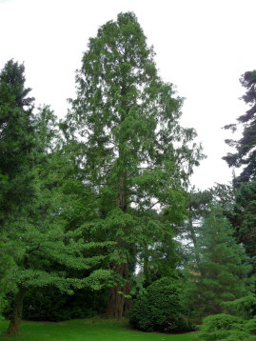
In Cantonspark, Baarn, Holland—beautiful.
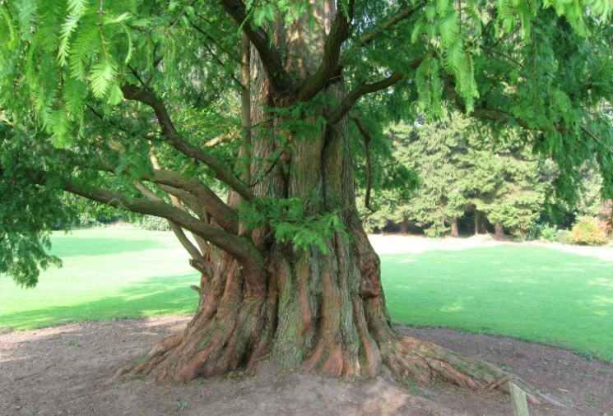
A fine specimen stands in Kalheupink, Oldenzaal, Holland. The broad irregular trunk is typical.

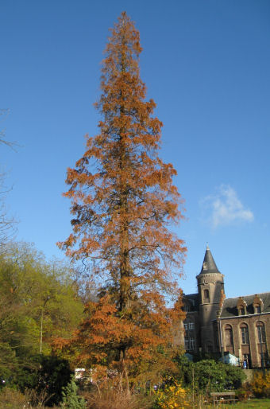
Autumn colours—Botanical Gardens, Ghent University.

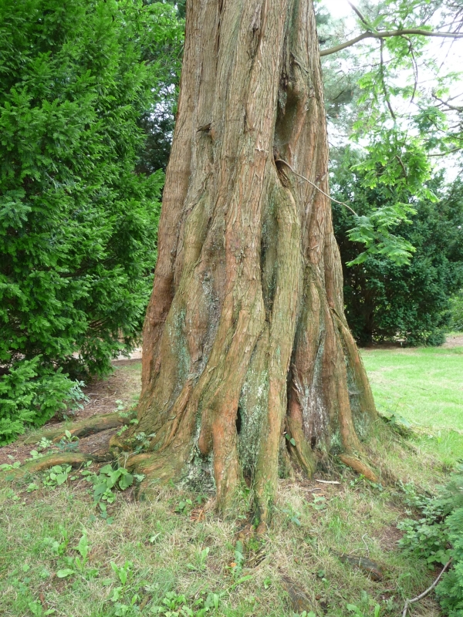
Lower trunk detail—Cantonspark, Baarn, Holland.

Fast maturing trees are now growing in botanical Gardens and parks world-wide. So just maybe the way in which this spectacular tree has re-emerged and spread throughout the world is also symbolic of the present spiritual mission.

________________________________________

Communication from Gyorgyi Szabo (who contributed to our book Foreword): “On 31st October, with the attendance of our dear Ervin Laszlo, I was awarded a PhD summa cum laude by the Sorbonne. So Halloween will always be very dear to me as a memory!
Gyorgyi”
Congratulations Gyorgyi—we are so pleased for you!!!

___________________________________

